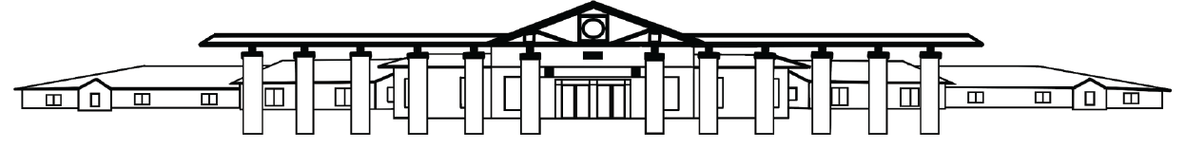

Pick Elementary School
Transportation Form

I hereby give permission for my child, _____________________________, to travel home by:

_____ Car

_____ Daycare Van

_____ Walk or Ride a Bike

_____ PES ASP

_____ Bus #_______ Bus Stop:__________________________________________

Student Home Address:_________________________________________

Rather than his/her regular mode of transportation:_________________ (NA for initial form)

On the following date(s):__________________________________________

Homeroom Teacher:______________________________

Parent/Guardian Signature:________________________________________

Parent/Guardian Phone Number: __________________________________

Note: This form is required every time your child changes his/her mode of transportation home. Please send this form to school or email the form to
kweaver@auburnschools.org before 1:30 pm, so changes can be made.

In granting permission, I hereby expressly waive my claim for liability against Auburn City School, the Board of Education, including its employees and representatives and release them from liability in connection with this trip. Further, I assume full responsibility for any damage to person and/or property caused by my student. I further expressly agree that in the event disciplinary action may be necessary, my child may be returned home at my expense. Further, in case of an emergency or injury to my student, I hereby authorize the school to act in the best interest of my student. I further consent and will be responsible to any medical and/or dental treatment that may be advisable at the discretion of any physician or dentist. I understand that I will be personally notified if it becomes for my student to be returned home and/or require health treatment. It is further warranted that if this Trip Permission Form is signed by one of two parents/guardians, it is with the authority of the other.

Office/Administration Approval: _____________________

